**Prototype 2 Name _________________________________________________**

1. **Form including your complete URL**

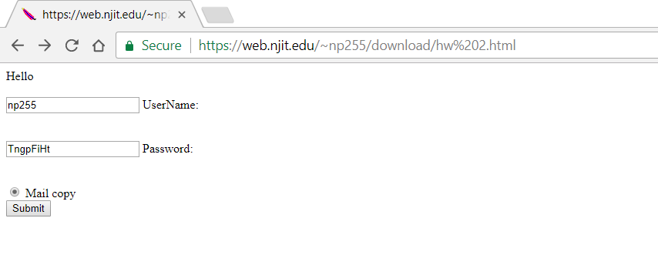

1. **Result of Form submission with box checked.**

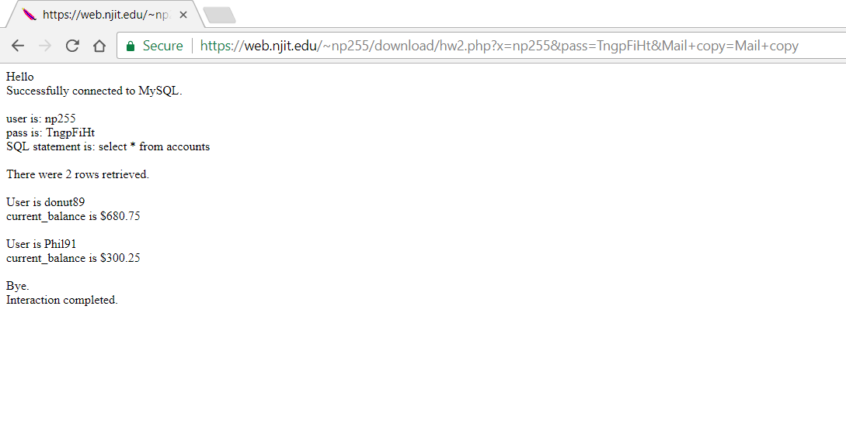

1. **HTML** code eg in Notepad++.

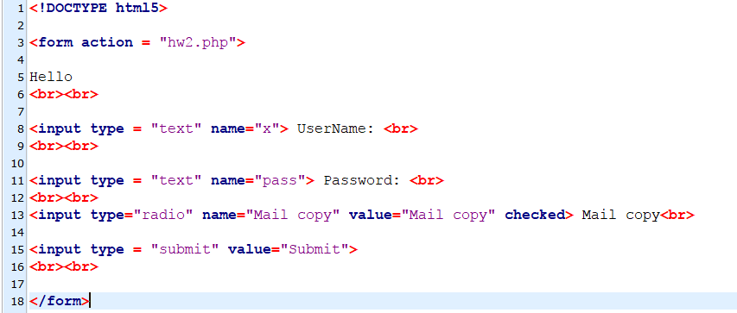

1. **PHP** code eg in Notepad++.

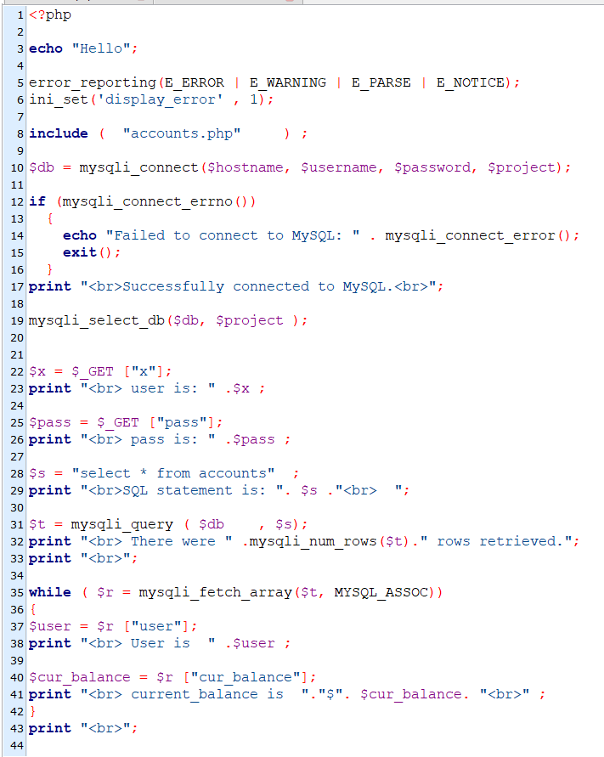

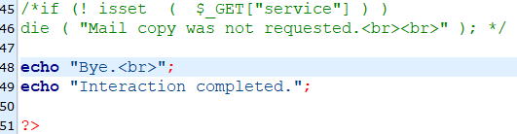

1. **PHP Syntax tool.**

**Parse error: syntax error, unexpected '/' in hw2(2).php on line 51**



**5B. Execute** the same PHP code as for 5a by submitting the form that triggers the program and snapshot the error page in Chrome including your url.

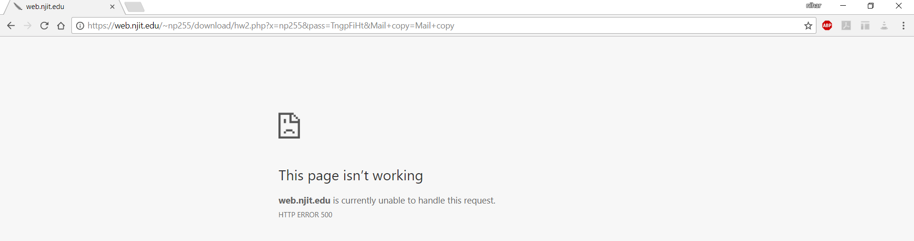

**5C. Execute** the form.php code but misspell name of one of the mysqli_ functions and snapshot browser result.

